**Project Design Phase-I**

**Solution Architecture**

|  |  |
| --- | --- |
| Date | 16/10/2022 |
| Team ID | PNT2022TMID12315 |
| Project Name | Digital Naturalist-AI Enabled Tool For Biodiversity Researches |
| Maximum Marks | 4 Marks |

**Solution Architecture:**

**A complicated process with numerous sub-processes, solution architecture connects business issues with technological solutions. Its objectives are to**

**• Track down the most effective technological remedy for current business issues.**

**• Explain to project stakeholders the structure, traits, behaviour, and other features of the software.**

**• Specify the features, stages of development, and requirements for the solution.**

**• Offer guidelines for how the solution is created, managed, and delivered.**

**Solution Architecture Diagram:** 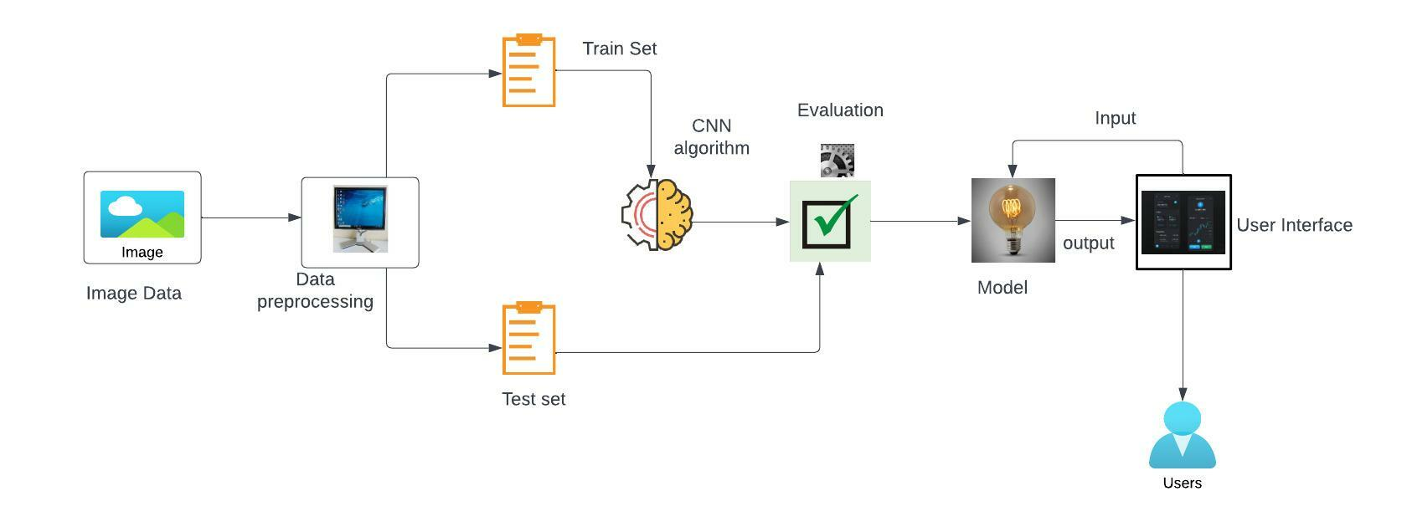

Digital Naturalist-AI Enabled Tool For Biodiversity Researches

**Reference:** [**https://aws.amazon.com/blogs/industries/voice-applications-in-clinical-research-powered-by-ai-on-aws-part-1-architecture-and-design-considerations/**](https://aws.amazon.com/blogs/industries/voice-applications-in-clinical-research-powered-by-ai-on-aws-part-1-architecture-and-design-considerations/)